Chaturvedi, Sumeet (Cognizant)

Sumeet.chaturvedi@cognizant.com

Project manager

A Full Stack Application Case Study

Contents

User 1

Welcome Page/Add User – 1

Update User 2

Project 3

Add project 3

Update Project 4

Task 5

Add Task 5

Update Task 5

View Task 6

Project Manager Case Study

Screen Shots –

# User

## Welcome Page/Add User –

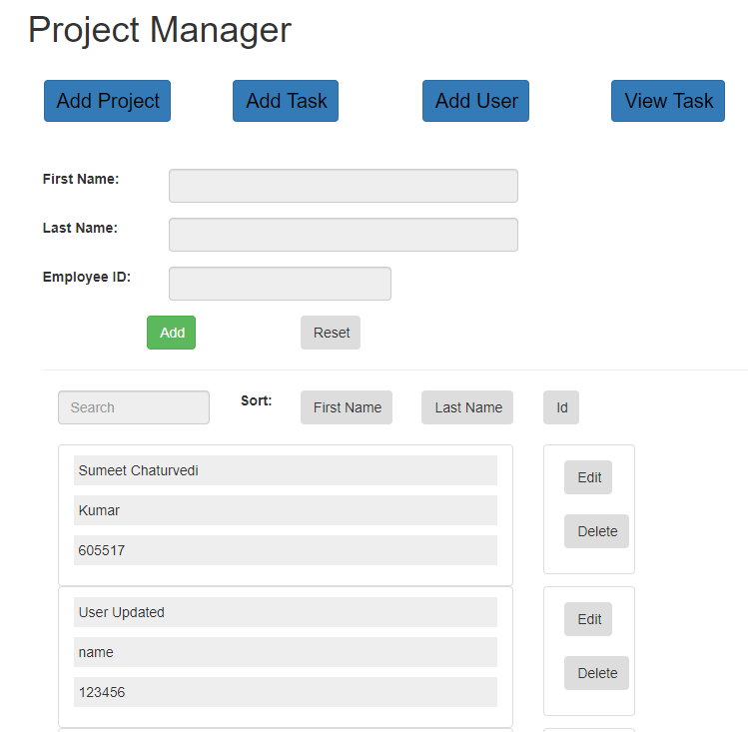

## Update User

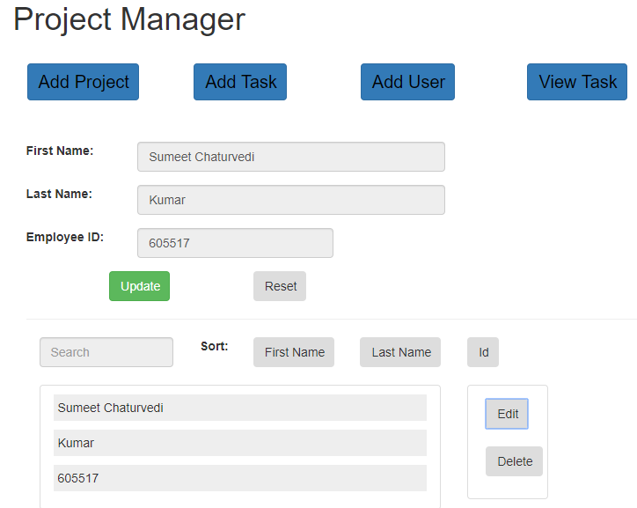

# Project

## Add project

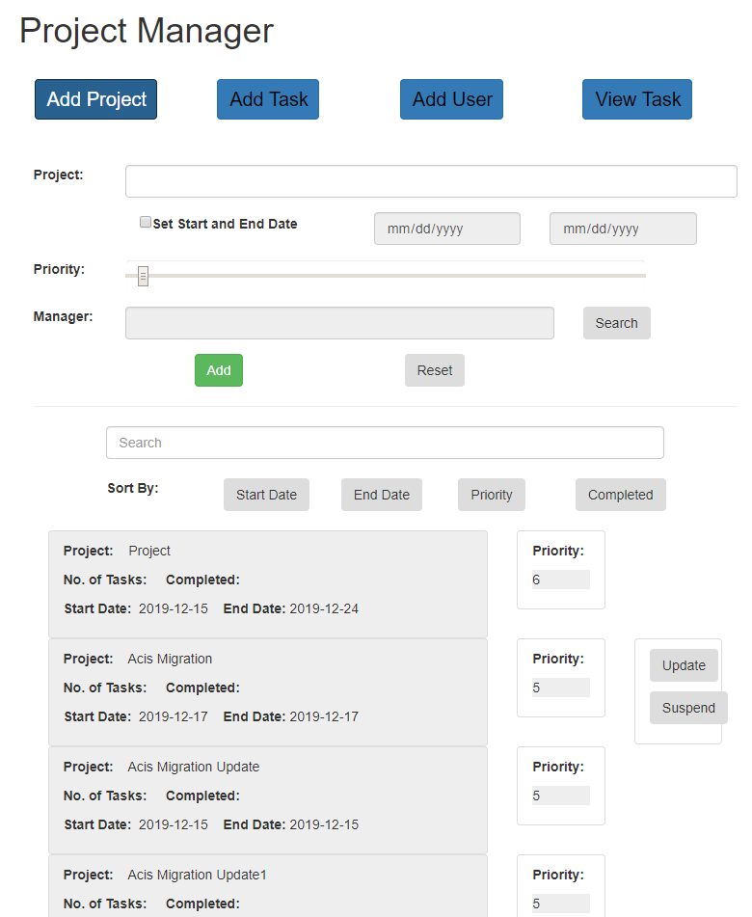

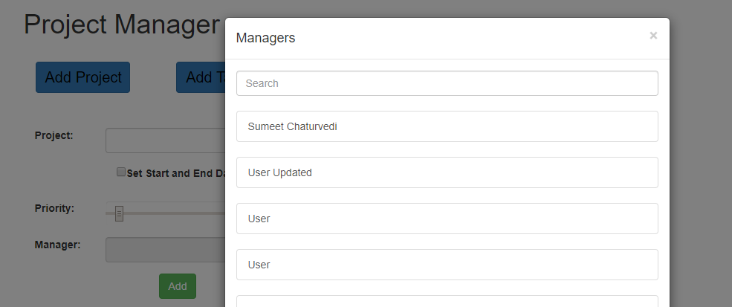

## Update Project

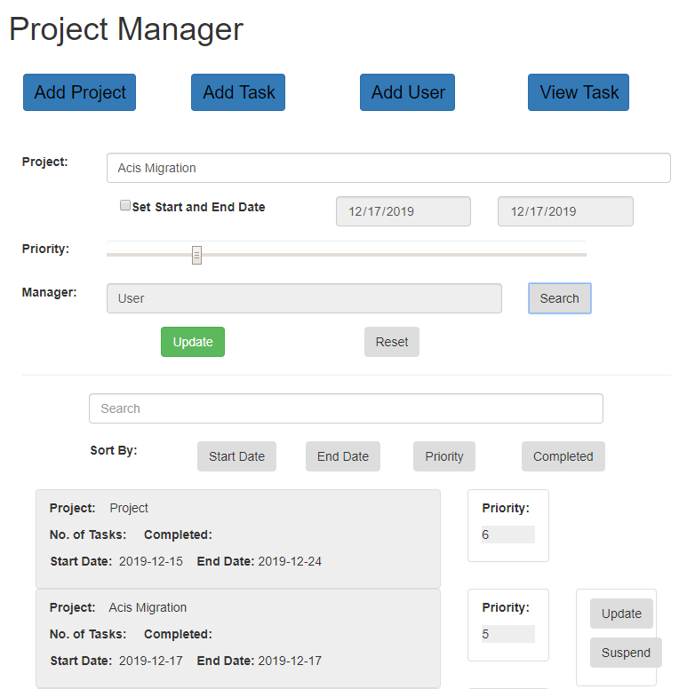

# Task

## Add Task

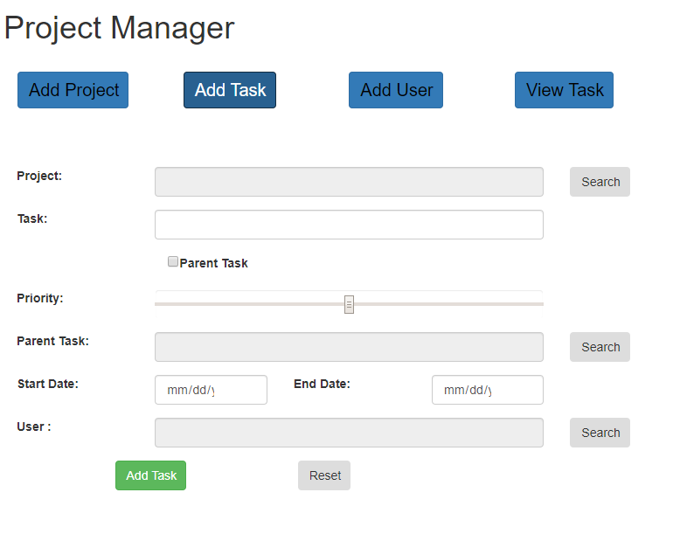

## Update Task

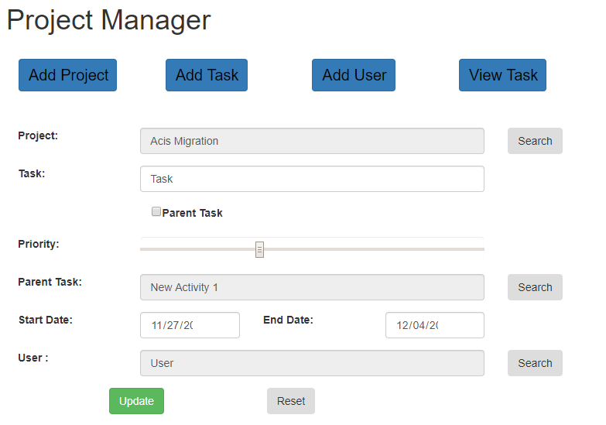

## View Task

